AM000-Asia-Japan-Edo-Dragon-Eight Arc-

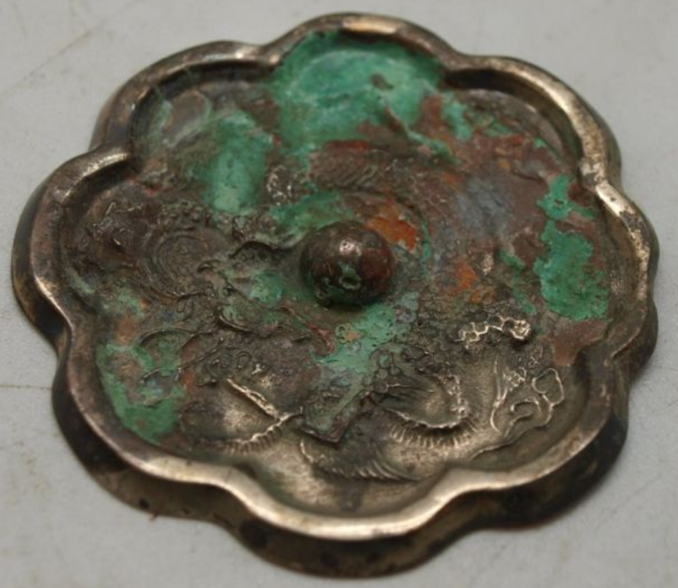

Asia-Japan-Edo-Dragon-Eight Arc-

Oriental Dragon - Silver Plated - 55mm

Stunning bronze Japanese mirror measuring 55mm in diameter.  This bronze mirror is silver plated, but has been heavily tarnished.  The back is decorated with primitive scenes of an oriental dragon.  It has a central boss which is pierced to allow a cord to be passed through for holding.  The other side is undecorated and would have originally been polished to create a reflective surface.

Japanese dragons (日本の竜 Nihon no ryū) are legendary amalgamations of native and Chinese legends of water deities associated with rainfall depicted as large, wingless, serpentine creatures with clawed feet and may have their origins with the alligators of coastal regions which come to spawn on banks during the rainy season.

Modern Japanese has numerous "dragon" words, including indigenous Tatsu from Old Japanese ta-tu, Sino Japanese ryū or ryō [竜](https://en.wiktionary.org/wiki/竜) from Chinese lóng [龍](https://en.wiktionary.org/wiki/龍), nāga ナーガ from Sanskrit [nāga](https://en.wikipedia.org/wiki/Nāga).

Buddhist monks from China brought dragon and snake legends such as the *nāga* ナーガ or 龍 "[Nāga](https://en.wikipedia.org/wiki/Nāga); rain deity; protector of Buddhism" and the *nāgarāja* ナーガラージャ or 龍王 ”[Nāgaraja](https://en.wikipedia.org/wiki/Nagaraja); snake king; [dragon king](https://en.wikipedia.org/wiki/Dragon_king)". Consequently Japanese [nāga](https://en.wikipedia.org/wiki/Nāga) legends incorported Chinese and Indian features: "This is quite clear, for it was via China that all the Indian tales came to Japan. Moreover, many originally Japanese dragons, to which Chinese legends were applied, were afterwards identified with [nāga](https://en.wikipedia.org/wiki/Nāga), so that a blending of ideas was the result" (de Visser 1913:179). For instance, the undersea palace where [nāga](https://en.wikipedia.org/wiki/Nāga) kings supposedly live is called Japanese ***ryūgū*** 龍宮 "dragon palace" from Chinese *longgong* 龍宮. Compare ryūgū-jō 龍宮城 "dragon palace castle", which was the sea-god Ryūjin's undersea residence. [Japanese](https://en.wikipedia.org/wiki/Japan) legends about the sea-god's tide jewels, which controlled the ebb and flow of tides, have parallels in Indian legends about the [nāga](https://en.wikipedia.org/wiki/Nāga)'s *nyoi-ju* 如意珠 "[cintamani](https://en.wikipedia.org/wiki/Cintamani); wish-fulfilling jewels".

Some additional examples of Buddhistic Japanese dragons are:

* *Hachidai ryūō* 八大龍王 "8 great naga kings" assembled to hear the Buddha expound on the [*Lotus Sutra*](https://en.wikipedia.org/wiki/Lotus_Sutra), and are a common artistic motif.
* *Mucharinda* ムチャリンダ "[Mucalinda](https://en.wikipedia.org/wiki/Mucalinda)" was the Nāga king who protected the Buddha when he achieved [bodhi](https://en.wikipedia.org/wiki/Bodhi), and is frequently represented as a giant cobra.
* [Benzaiten](https://en.wikipedia.org/wiki/Benzaiten) 弁才天 is the Japanese name of the goddess [Saraswati](https://en.wikipedia.org/wiki/Saraswati), who killed a 3-headed [Vritra](https://en.wikipedia.org/wiki/Vritra) serpent or dragon in the [*Rigveda*](https://en.wikipedia.org/wiki/Rigveda). According to the [*Enoshima Engi*](https://en.wikipedia.org/wiki/Enoshima_Engi), Benzaiten created [Enoshima](https://en.wikipedia.org/wiki/Enoshima) Island in 552 CE in order to thwart a 5-headed dragon that had been harassing people.

[Kuzuryū](https://en.wikipedia.org/wiki/Kuzuryu) 九頭龍 "9-headed dragon", deriving from the multi-headed Naga king シェーシャ or 舍沙 "[Shesha](https://en.wikipedia.org/wiki/Shesha)", is worshipped at [Togakushi Shrine](https://en.wikipedia.org/wiki/Togakushi_Shrine) in [Nagano Prefecture](https://en.wikipedia.org/wiki/Nagano_Prefecture).